**PROGRAM 21(a)**

**AIM- Print pattern using a for loop and range function.**

**1**

**2 2**

**3 3 3**

**4 4 4 4**

**5 5 5 5 5**

**Code:-**

n=int(input('Enter no of rows : '))

for i in range(1,n+1):

for j in range(i):

print(i,end='')

print(' ')

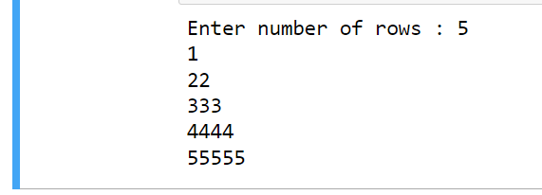 **OUTPUT:**

**PROGRAM 21(b)**

**Aim - Print pattern using a for loop and range function**

**1**

**2 1**

**3 2 1**

**4 3 2 1**

**5 4 3 2 1**

**Code -**

n=int(input(‘Enter no of rows : ’))

for i in range(1,n+1):

for j in range(1,i+1):

print(i-j+1,end=' ')

print('\n')

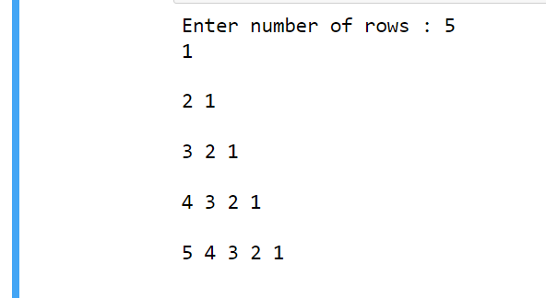**OUTPUT:**

**PROGRAM 22**

**Aim - To check a given number is even or odd.**

**Code -**

n=int(input("Enter the number: "))

if(n%2==0):

print(n,"is even")

else:

print(n,"is odd")

**OUTPUT:**

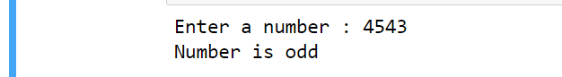

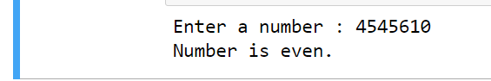

**PROGRAM 11**

**Aim - To print prime numbers between 1 and 20.**

**Code-**

n=int(input("Enter last number : "))

print('Prime numbers from 1 to 20 are : ')

for i in range(1,n+1):

if i>1:

for j in range(2,i):

if i%j==0:

break

else:

print(i)

**OUTPUT:**

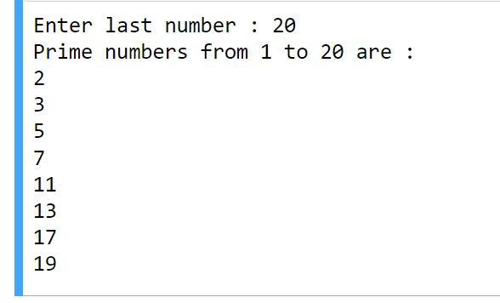

**PROGRAM 23**

**Aim - To find sum of all digits of a given number**

Code -

n=int(input('enter number : '))

sum=0

while n!=0:

r=n%10

sum=sum+r

n=n//10

print(sum,'is sum of digits.')

**OUTPUT:**

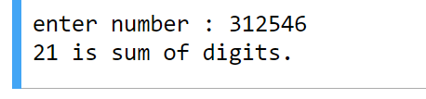

**PROGRAM 24**

**Aim - To check the number is palindrome or not.**

**Code -**

n=int(input("Enter a number : "))

t=n

rev=0

while n!=0:

d=n%10

rev=rev*10+d

n=n//10

if t==rev:

print("The number is palindrome")

else:

print("The number is not palindrome")

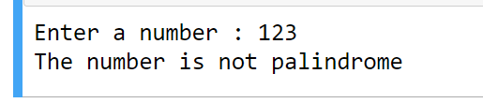**OUTPUT:**

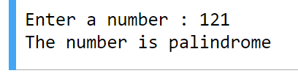

**PROGRAM 2**

**Aim - Write a program to perform different arithmetic operations on numbers in Python.**

**Code :-**

while True:

a=int(input("Enter first number:"))

b=int(input("Enter second number:"))

print("1 Addition \n 2 Subtraction \n 3 Multilication \n 4 Normal Division\n 5 Floor Division \n6 Modulus")

n=int(input())

if(n==1):

sum=a+b

print("Addition of given numbers is: ",sum)

elif(n==2):

sub=a-b

print("Subtraction of two given number is:",sub)

elif(n==3):

mul=a*b

print("Multilication of two number:",mul)

elif(n==4):

div=a/b

print("Division of two number is: ",div)

elif(n==5):

Fdiv=a//b

print("Floor Division of two number is: ",Fdiv)

elif(n==6):

mod=a%b

print("Modulus is: ",mod)

else:

print("Enter number between 1 and 6")

x=int(input("Do you want to continue? "))

if(x!=’y’):

break

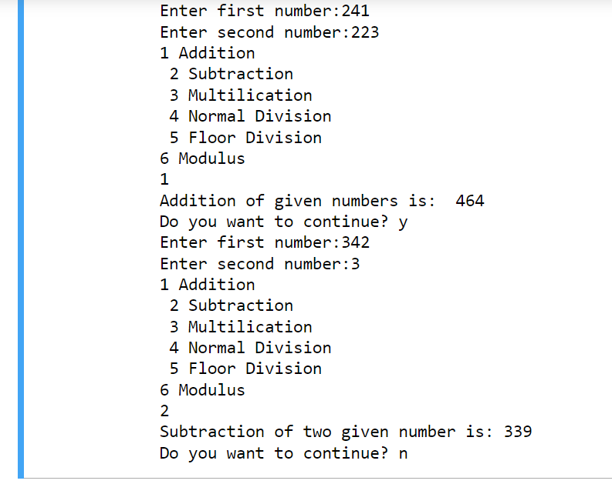**OUTPUT:**

**PROGRAM 8**

**Aim - Write a python program to find largest of three numbers.**

**Code -**

a=int(input("Enter first element : "))

b=int(input("Enter second element : "))

c=int(input("Enter third element : "))

if (a>b):

if a>c:

print(a," is greater.")

else:

print(c," is greater.")

if b>a:

if b>c:

print(b," is greater.")

else:

print(c," is greater.")

**OUTPUT:**

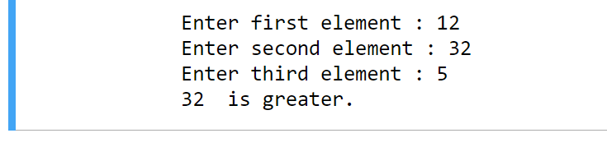

**PROGRAM 9**

**Aim - Write a program to convert to and from Celsius, Fahrenheit .**

**Code :-**

while(True):

n=int(input('''Select one option:

1. Convert Celsius to Fahrenheit.

2.Convert Fahrenheit to Celsius.\n'''))

if(n==1):

c=int(input("Enter the temperature in Celsius: "))

f=int(1.8*c+32)

print("Temperature in Fahrenheit: ",f)

elif(n==2):

fh=int(input("Enter the temperature in Fahrenheit:"))

ch=int((fh-32)/1.8)

print("Temperature in Celsius: ",ch)

x=input("Do you want to continue? : ")

if(x!='y'):

break;

**OUTPUT:**

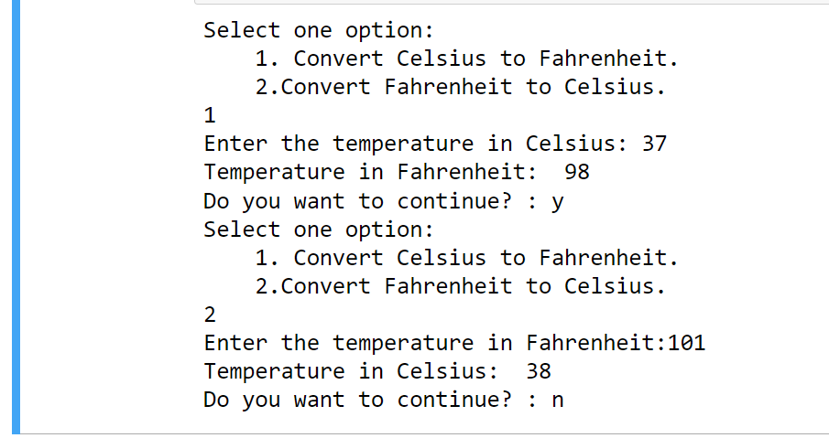

**PROGRAM 10**

**Aim - Print the following Pattern:**

**\***

**\* \***

**\* * \***

**\* * * \***

**\* * * * \***

**\* * * \***

**\* * \***

**\* \***

**\***

**Code -**

n=int(input('enter number of columns : '))

for i in range(1,n):

for j in range(i):

print('*',end='')

print(' ')

for i in range(n,0,-1):

for j in range(i):

print('*',end='')

print(' ')

**OUTPUT:**

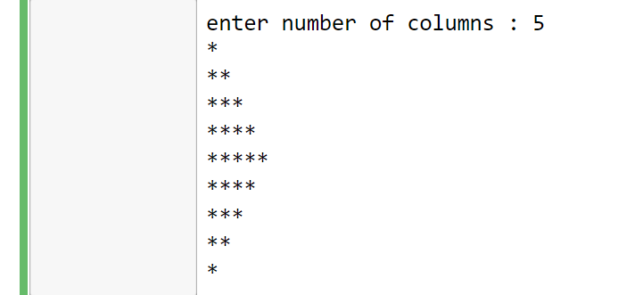

**PROGRAM 25**

**Aim - Check if a substring is present in a given string**

**Code -**

str=input("Enter the string: ")

x=input("Enter the substring: ")

if x in str:

print("Substring is present in string")

else:

print("Substring is not present in string")

**OUTPUT:**

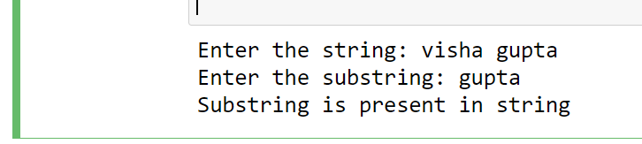

**PROGRAM 26**

**Aim - Program to find even length words in a string.**

**Code -**

str=input("Enter the string: ")

x=str.split(' ')

print("The words with even length :")

for i in x:

if(len(i)%2==0):

print(i)

**OUTPUT:**

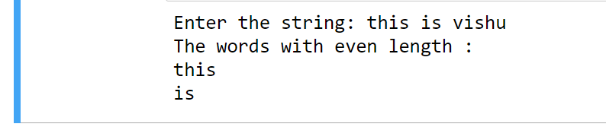

**PROGRAM 27**

**Aim - Program to swap all dots with commas in string.**

**Code -**

str=input("Enter the string: ")

x=input("Enter the substring: ")

if x in str:

print("Substring is present in string")

else:

print("Substring is not present in string")

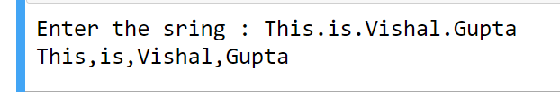**OUTPUT:**

**PROGRAM 28**

**Aim - Given a string “F.R.I.E.N.D.S”, change the string to “friends”**

**Code -**

s='F.R.I.E.N.D.S'

str1=s.replace(".","")

print('your output is : \n',str1.lower())

**OUTPUT:**

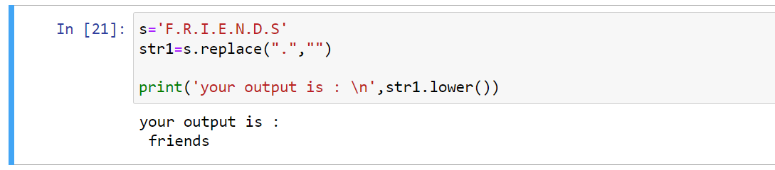

**PROGRAM 29**

**Aim - Extract digits of string from a given string.**

**Code -**

s1=input('Enter a string : ').split()

print(s1)

for i in s1:

for j in i:

if j.isdigit():

print(j,end='')

print('')

**OUTPUT:**

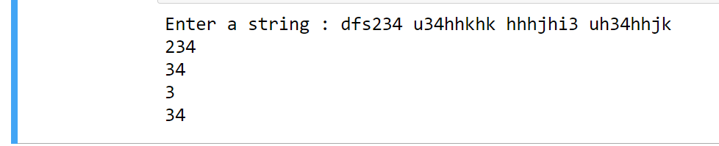

**PROGRAM 12**

**Aim** : **Write a python program to find factorial of a number using Recursion.**

**Code:-**

a=int(input("Enter the number whose factorial you want : "))

def factorial(a):

if a==1:

return 1

else:

return a*factorial(a-1)

print("Factorial of ",a ," is ",factorial(a))

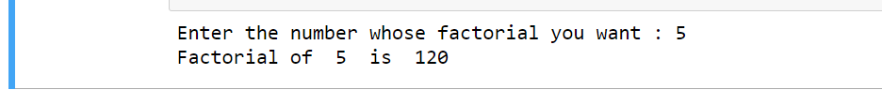**Output:-**

**Practical – 13**

**Aim :- Write a program that accepts the lengths of three sides of a triangle as inputs. The program output should indicate whether or not the triangle is a right triangle.**

**Code :-**

a=int(input("Enter ist side : "))

b=int(input("Enter 2nd side : "))

c=int(input("Enter 3rd side : "))

if a**2+b**2==c**2 or b**2+c**2==a**2 or c**2+a**2==b**2:

print("Triangle is a Right Triangle")

else:

print("Triangle is not a Right Triangle")

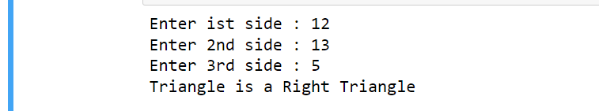**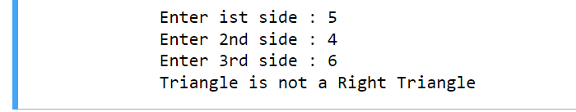Output:-**

**Practical – 14**

**Aim :- Write a python program to define a module to find Fibonacci Numbers and import the module to another program.**

**Code:-**

import fact_module as f

a=int(input("Enter the number whose factorial you want : "))

print("Factorial of ",a ," is ",f.factorial(a))

**Output:-**

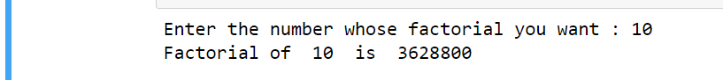

**Practical – 15**

**Aim:-** **Write a python program to define a module and import a specific function in that module to another program.**

**Code:-**

import basic_math as bm

a=int(input("Enter first number : "))

b=int(input("Enter second number : "))

print("Addition of ",a," and ",b," is : ",bm.sum(a,b))

print("subtraction of ",a," and ",b," is : ",bm.sub(a,b))

print("Multiplication of ",a," and ",b," is : ",bm.multiply(a,b))

**Output:-**



**Practical – 16**

**Aim:-** **Write a script named copyfile.py. This script should prompt the user for the names of two text files. The contents of the first file should be input and written to the second file.**

**Code:-**

file1=input("Enter The File_Name: ")

file2=input("Enter The File_Name: ")

f1=open(file1,"r")

f2=open(file2,"w")

z=f1.readlines()

for i in range(0,len(z)):

f2.write(z[i])

print("Data coppied sucessfully")

f2.close()

**Output:-**

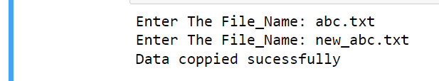

**Program-17**

**Aim:-** **Write a program that inputs a text file. The program should print all of the unique words in the file in alphabetical order.**

**Code:-**

file=open("file.txt","w")

file.write("hello what are you doing hello are here hello what are you")

file=open("file.txt","r")

f1=file.read()

res=sorted(set(f1.split(" ")))

print("All uique words are : ")

for i in res:

print(i)

**Output:-**

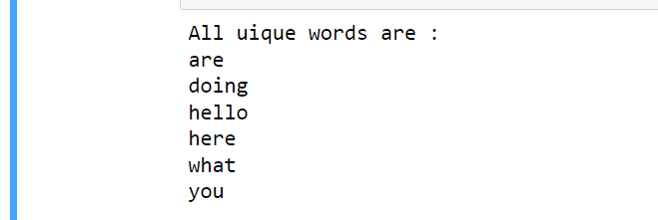

**Practical :- 4**

**Aim:- Write a python script to print the current date in the following format “Sun May 29 02:26:23 IST 2017”.**

**Code :-**

import time;

y=time.localtime();

print("The Time and Date is : ")

print(time.strftime("%a %b %d %H:%M:%S %Z %Y",y))

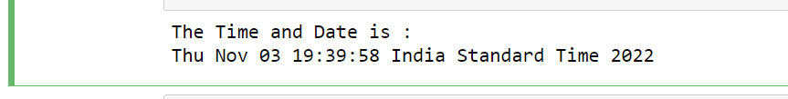**Output:-**

**Practical : - 1**

**Aim :-** **Write a program to demonstrate different number data types in Python.**

**Code:-**

a = 5

print(a, "is of type", type(a))

a = 2.0

print(a, "is of type", type(a))

a = 1+2j

print(a, "is complex number?", isinstance(1+2j,complex))

a=[1,2,3,4]

print(a, "is of type", type(a))

a=(1,2,3,4)

print(a, "is of type", type(a))

a={1:2,2:3,3:4}

print(a, "is of type", type(a))

a=True

print(a, "is of type", type(a))

a=(1,2,3,4)

print(a, "is of type", type(a))

a="Vishal Gupta"

**Output :-**

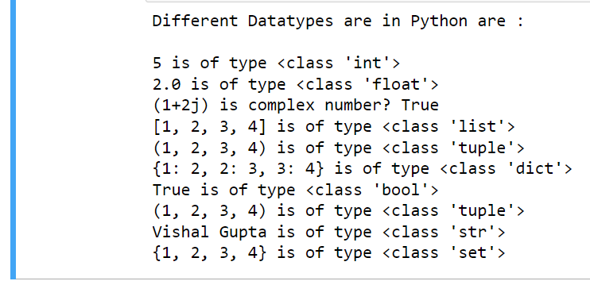

print(a, "is of type", type(a))

a={1,2,3,4}

print(a, "is of type", type(a))

**Practical – 5**

**Aim :-** **Write a program to create, append, and remove lists in python.**

**Code:-**

b=1

while b!=5:

inpt=int(input('''Enter your choice :

Enter 1 to create a list.

Enter 2 to append in a list.

Enter 3 to remove element from a list.

Enter 4 to show list.

Enter 5 to exit.'''))

if inpt==1:

li=[]

n=int(input('Enter number of elements : '))

for i in range(n):

ele=int(input('Enter element '))

li.append(ele)

print('list created sucessfully')

elif inpt==2:

a=input('Enter element which you want to append : ')

li.append(a)

print('element appended sucessfully')

elif inpt==3:

a=input('Enter element which you want to remove : ')

li.remove(a)

print('element removed sucessfully')

elif inpt ==4:

print("your list is : ",li)

elif inpt >=5:

break

b=b+1

a=input("do you want to continue (y/n): ")

if a!='y':

break

**Output:-**

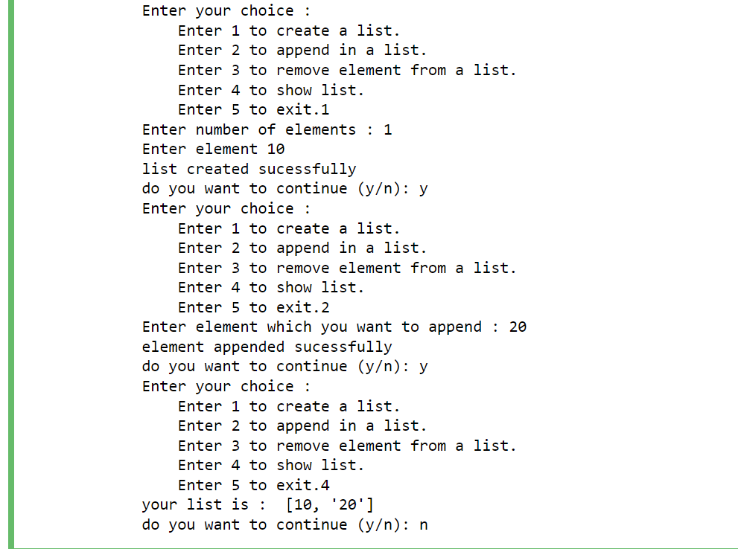

**Practical – 6**

**Aim :-** **Write a program to demonstrate working with tuples in python.**

**Code:-**

b=1

while b!=5:

inpt=int(input('''Enter your choice :

Enter 1 to create a list.

Enter 2 to append in a list.

Enter 3 to remove element from a list.

Enter 4 to show list.

Enter 5 to exit.'''))

if inpt==1:

li=[]

n=int(input('Enter number of elements : '))

for i in range(n):

ele=int(input('Enter element '))

li.append(ele)

print('list created sucessfully')

elif inpt==2:

a=input('Enter element which you want to append : ')

li.append(a)

print('element appended sucessfully')

elif inpt==3:

a=input('Enter element which you want to remove : ')

li.remove(a)

print('element removed sucessfully')

elif inpt ==4:

print("your list is : ",li)

elif inpt >=5:

break

b=b+1

a=input("do you want to continue (y/n): ")

if a!='y':

break

**Output:-**

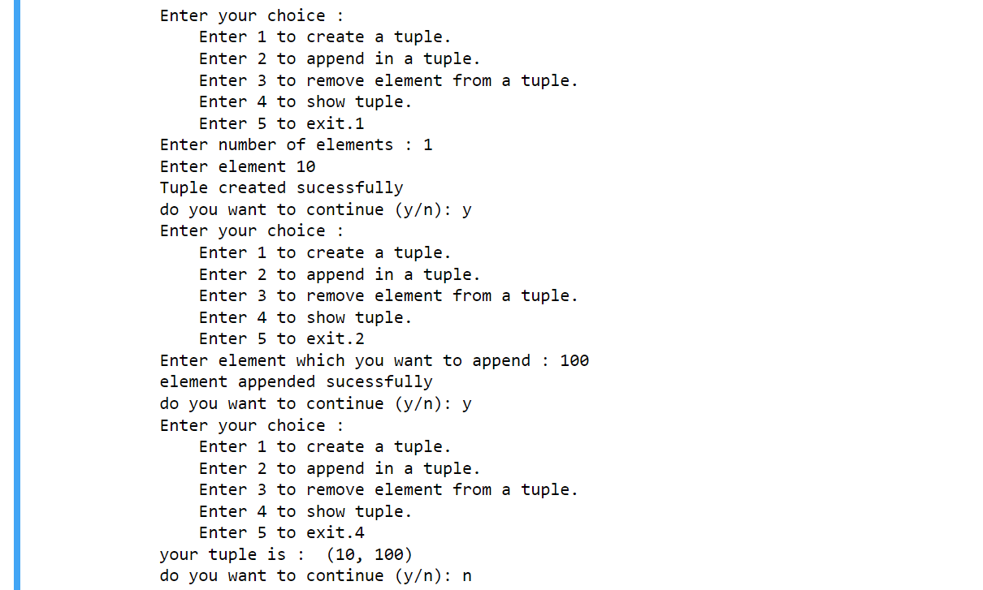

**Practical – 7**

**Aim :-** **Write a program to demonstrate working with dictionaries in python.**

**Code:-**

b=1

while b!=5:

inpt=int(input('''Enter your choice :

Enter 1 to create a dictionary.

Enter 2 to display key value pairs.

Enter 3 to display keys and values saperately.

Enter 4 to removing elements.

Enter 5 to exit.'''))

if inpt==1:

key=[]

value=[]

n=int(input('Enter no of elements : '))

for i in range(n):

ele=input('Enter key ')

key.append(ele)

key1=tuple(key)

for i in range(n):

ele=input('Enter value ')

value.append(ele)

value1=tuple(value)

dict1=dict(zip(key1,value1))

print('you created a dictionary successfully : \n The dictionary is : \n',dict1)

elif inpt==2:

it=dict1.items()

for i in it:

print(i)

elif inpt==3:

k=dict1.keys()

v=dict1.values()

print('keys of the dictionary are :\n')

for i in k:

print(i)

print('values of the dictionary are :\n')

for i in v:

print(i)

elif inpt==4:

print(dict1.keys())

r=input('Enter key of that element which you want to remove : ')

p=dict1.pop(r)

print(p,'is removed.')

if inpt >=5:

break

b=b+1

a=input("do you want to continue (y/n): ")

if a!='y':

break

**Output:-**

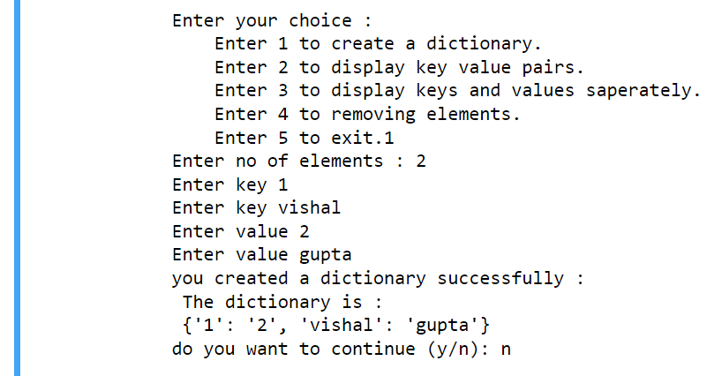

**Practical – 3**

**Aim :-** **Write a program to create, concatenate and print a string and accessing sub-string from a given string.**

**Code:-**

a=1

while a!=5:

inp=int(input('''Enter your choice :

Enter 1 to create a string.

Enter 2 to concatinate a string.

Enter 3 to print a string.

Enter 4 to acessing a substring.

Enter 5 to exit.'''))

if inp ==1:

st=input('Enter a string : ')

print('string created sucessfully')

if inp ==2:

s=input('Enter a string : ')

st1=input('Enter string which you want to concatinate : ')

st2=s+st1

print('your concatinated string is : ',st2)

if inp==3:

x=int(input('Enter 1 to print original string : \n print 2 to print concatinated string: '))

if x==1:

print(st)

if x==2:

print(st2)

if inp==4:

def findchar(string,c):

for i in range(0,len(string)):

if string[i]==c:

return 'The index of ', string[i],' in given string is : ',i

return -1

string=input('Enter a string : ').split()

c=input('enter substring which you want to find : ')

print(findchar(string,c))

if inp>=5:

break

a=a+1

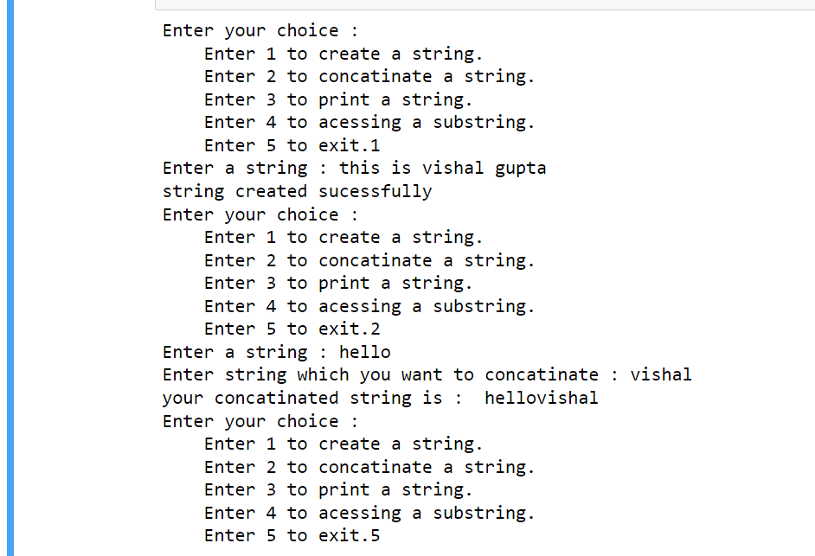**Output:-**

**Practical – 30**

**Aim :-** **Write a program to insert element in list before any element.**

**Code:-**

li=[]

n=int(input('Enter no of elements : '))

for i in range(n):

ele=int(input('Enter element : '))

li.append(ele)

print('List created sucessfully')

print(li)

n1=int(input('Enter the element where you want to insert element : '))

n_ele=int(input("Enter element which you want to insert : "))

ind=li.index(n1)

li.insert(ind,n_ele)

print('element inserted sucessfully')

print(li)

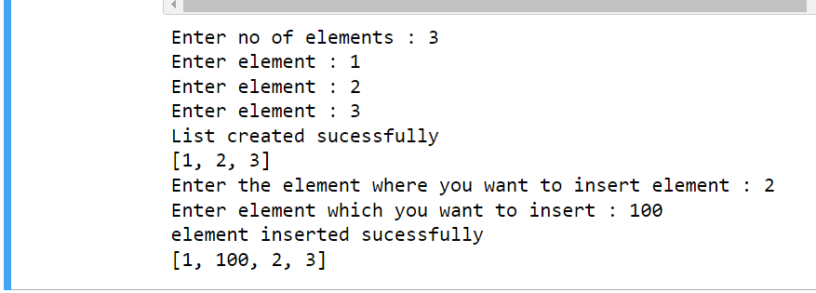**Output:-**

**Practical – 31**

**Aim :-** **Write a program to remove consonants from a string.**

**Code:-**

st=input("Enter string : ")

for i in st:

if i=='a' or i=='u'or i=='e' or i=='i'or i=='o':

print(i,end='')

else:

st.replace(i,'')

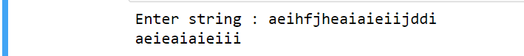**Output:-**

**Practical – 32**

**Aim :-** **Write a program to print abbreviation of first and middle name.**

**Code:-**

name=input('Enter your name : ')

s_name =name.split()

l=len(s_name)

for i in s_name:

if s_name.index(i)<=l-2:

print(i[0].upper(),end='.')

else:

print(i.capitalize())

**Output:-**

**Practical – 33**

**Aim :-** **Write a program to count no of Alphabet in given string and print them in alphabetical order by using dictionary.**

**Code:-**

iput=input()

iput=iput.upper()

ct={}

for i in iput:

c=iput.count(i)

ct[i]=c

d_sort=sorted(ct.items())

for alpha,count in d_sort:

print(alpha,':',count)

**Output:-**

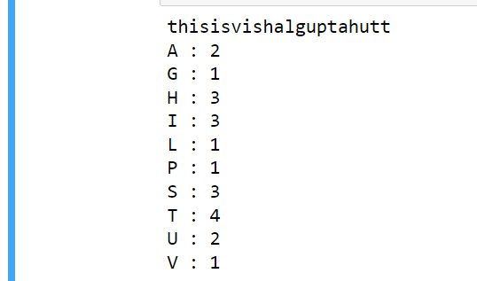

**Practical – 34**

**Aim :-** **Write a program to perform scalar multiplication of a number with the given list.**

**Code:-**

def input_list(n):

li=[]

for i in range(n):

num=int(input('Enter element : '))

li.append(num)

return li

def scalar_multiply(li,num):

li1=[]

for i in li:

li1.append(i*num)

return li1

n=int(input('Enter no of elements : '))

list_1=input_list(n)

num1=int(input('Enter number which you want to mltiply : '))

print('scalar multiplication is : ',scalar_multiply(list_1,num1))

**Output:-**

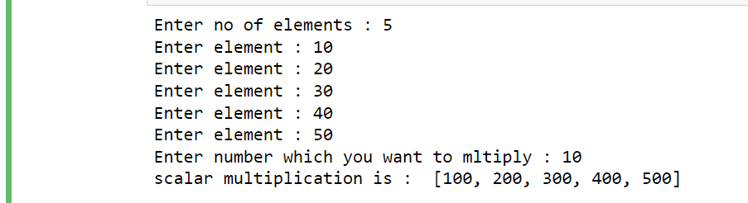

**Practical – 35**

**Aim :-** **Write a program to print number of occurrences of all items of the list in the tuple .**

**Code:-**

li=input('Enter elements for list with space : ').split()

t=tuple(input('Enter elements for tuple with space : ').split())

d={}

for i in li:

d[i]=t.count(i)

print('count of elements of list in tuple : ')

for i,j in d.items():

print(i,'-',j)

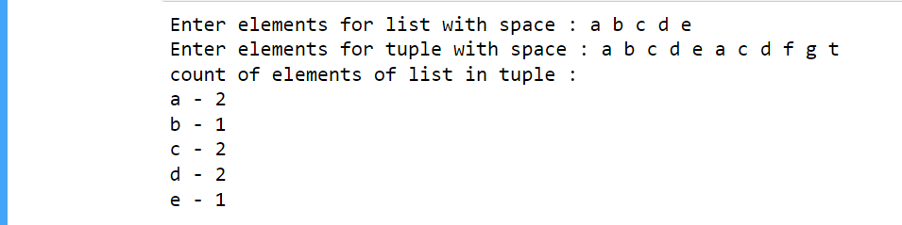**Output:-**

**Practical – 36**

**Aim :-** **Write a program to remove Nth occurrence of the given word in the list.**

**Code:-**

lis=['you','can','do','you','vishal','are','the','vishal','best']

d={}

for i in lis:

d[i]=lis.count(i)

l=list(d.keys())

print(l)

**Output:-**

**Practical – 37**

**Aim :-** **Write a program to print mirror image of given alphabet by using dictionary.**

**Code:-**

a='abcdefghijklmnopqrstuvwxyz'

x=[],y=[]

for i in a:

x.append(i)

for j in a[::-1]:

y.append(j)

dic=dict(zip(x,y))

v=input('Enter Alphabet whose mirror image you want : ')

print('Mirror image of ',v,' is : ',dic[v])

**Output:-**

**Practical – 38**

**Aim :-** **Write a program to merge two dictionaries.**

**Code:-**

d={'Ten':10,'Twenty':20,'Thirty':30}

d1={'Thirty':30,'Fourty':40,'Fifty':50}

print(d|d1)

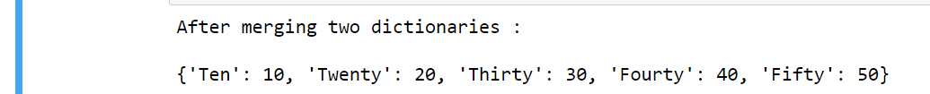**Output:-**

**Practical – 39**

**Aim :-** **Write a program that takes text file as a input and returns the number of words of a given text file.**

**Code:-**

f=open('words.txt','w')

f.write('hello this is vis,hal gupta from jammu and kashmir vishalsiv jhsjf amanama vissiv vishalvis jdkjf sdjhk')

f=open('words.txt','r')

f1=f.read()

x=f1.split()

print('Number of words in file : ',len(x))

**Output:-**



**Practical – 40**

**Aim :-** **Write a program to count the number of lines in a text file.**

**Code:-**

f=open('words.txt','w')

f.write('''hello this is vishal gupta

from jammu and kashmir

vishalsiv jhsjf amanama

vissiv vishalvis jdkjf sdjhk

hii how r u

i am fine dear''')

f=open('words.txt','r')

f1=f.readlines()

print(len(f1))

**Output:-**



**Practical – 41**

**Aim :-** **Write a program to count the occurrence of each word in given text file by using dictionary.**

**Code:-**

f=open('words.txt','w+')

f.write('Never give in. Never give in Never or never never never-in nothing great')

f.seek(0)

f1=f.read().split()

d={}

print("Number of counts of : ")

for i in f1:

d[i]=f1.count(i)

for i in d.items():

for j in i:

print(j,end=" ")

print('')

**Output:-**

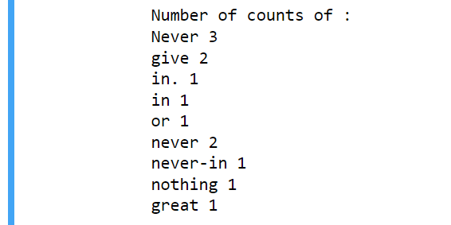**Practical – 42**

**Aim :-** **Write a program to Eliminate repeated lines from a file.**

**Code:-**

op=open('sample.txt','r')

r=op.readlines()

op=open('sample1.txt','w+')

d={}

for i in r:

d[i]=r.count(i)

for i in d:

op.write(i)

op.seek(0)

o=op.readlines()

for i in o:

print(i)

**Output:-**

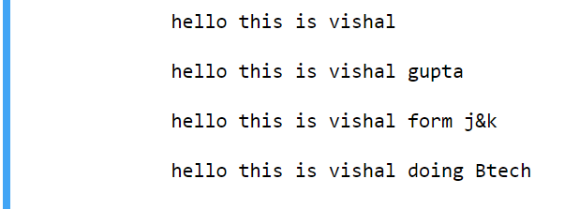

**Practical – 43**

**Aim :-** **Write a program to print the sum of all digits that are in file.**

**Code:-**

f=open('new.txt','w')

f.write('1258346983746hjdfskjfjkdj djfkjh5k34') , f.seek(0)

f1=f.read()

sum=0

for i in f1:

if i.isdigit():

sum=sum+int(i)

print("sum of all digits is : ",sum)

**Output:-**



**Practical – 44**

**Aim :-** **Write a program to return a string with the equivalent English text of each digit.**

**Code:-**

d={1:'One',2:'Two',3:'Three',4:'Four',5:'Five',6:'Six',7:'Seven',8:'Eight',9:'Nine',0:'Zero'}

i=input('Enter number : ')

for j in i:

if j==i[-1]:

print(d[int(j)],end=' ')

else:

print(d[int(j)],end='-')

**Output:-**

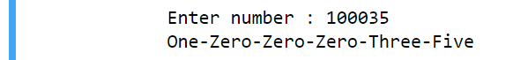

**Practical – 45**

**Aim :-** **Write a program to find what percent of words start with a vowel in a text file.**

**Code:-**

f=open('words.txt','w')

f.write('''hello ethis is uvishal ogupta

from ammu and ashmir fghfdf gdfh dsdfdhd

ishalsiv ohsjf amanama ''')

f=open('words.txt','r')

f1=f.read()

f=f1.split()

tw=len(f)

li=[]

for i in f:

if i[0]=='a' or i[0]=='A' or i[0]=='e' or i[0]=='E' or i[0]=='i' or i[0]=='I' or i[0]=='o' or i[0]=='O' or i[0]=='u' or i[0]=='U':

li.append(i)

tv=len(li)

print('Total words in a file : ',tw)

print('Total no. of words that starts with vowels : ',tv)

t_per = tv/tw*100

print('Percentage of words that starts with vowels : ',round(t_per,2),'%')

**Output:-**

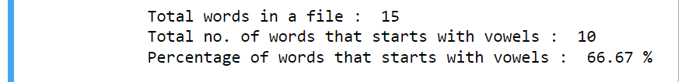

**Practical – 46**

**Aim :-** **Write a program to print 7 letter words that start with th and end with ly from the file.**

**Code:-**

f=open('words.txt','w')

f.write('hello this is vishal gupta from jammu and kashmir vishalsiv jhsjf amanama vissiv vishalvis thjjdfhsly thhfjhsbly dhfshthdjly bdhbsndb thnjdfhjsdly thbsnly')

f=open('words.txt','r')

f1=f.read()

f1=f1.split()

print('Following are the words that starts with th and end with ly : \n',i)

for i in f1:

if len(i)>=7:

if i[:2]=='th' and i[-2:]=='ly':

print(i)

**Output:-**

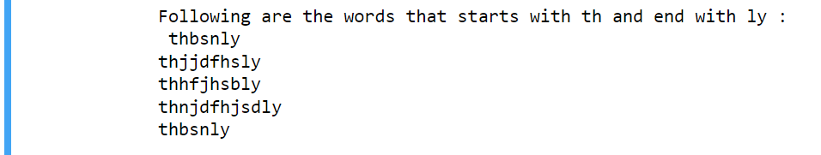

**Practical – 47**

**Aim :-** **Write a program to** **print all the words >=6 letters that start and end with same letters.**

**Code:-**

f=open('words.txt','w+')

f.write('hello this is vishal gupta from jammu and kashmir vishalsiv jhsjf amanama vissiv vishalvis')

f.seek(0)

f1=f.read()

f1=f1.split()

print(f1)

for i in f1:

if len(i)>=6:

if i[:3]==i[-3:]:

print(i)

**Output:-**

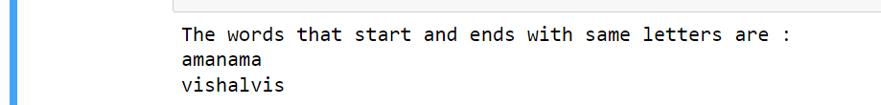

**Practical – 48**

**Aim :-** **Write a program to print longest word that starts and ends with the same letter.**

**Code:-**

f=open('words.txt','w+')

f.write('hello this is vishal thjht thjhjhjtfggdt thly gupta from jammu and kashmir vishalsiv jhsjf amanama vissiv vishalvis thjjdfhsly thhfjhsbly dhfshthdjly bdhbsndb thnjdfhjsdly thbsnly')

f.seek(0)

f1=f.read()

f1=f1.split()

d={}

# print('Words that starts and ends with same letters are : \n')

for i in f1:

if i[0]==i[-1]:

d[len(i)]=i

print(i)

print('\nThe longest word is : ',d[max(d)])

**Output:-**

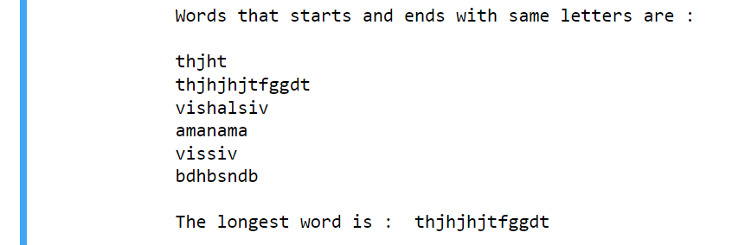

**Practical – 49**

**Aim :-** **Write a program to print the Letters which contains 4 alphabetically consecutive letters.**

**Code:-**

with open('consecutive.txt','w+') as f:

f.write('''The alphabetical sequence is contained in OVERSTUMBLE GHYTPLABCDHY HYTWRSTKL HIJKTPLDS and BIERSTUBE.

The only other four-letter alphabetical sequence found in English which GYMNOPLAST THAMNOPHILE.

If the alphabet is treated as a continuous loop however CREMNOPHOBIA there

ANALYZABLE''')

f.seek(0)

inpt=f.read().split()

print('Words that contains for consecutive letters are : \n')

for i in inpt:#vishu

if len(i)>=4:#true

for j in range(len(i)-1): #0

if len(i[j:])>=4:

if ord(i[j]) == ord(i[j+1])-1 and ord(i[j+1]) == ord(i[j+2])-1 and ord(i[j+2])==ord(i[j+3])-1:

l=i[j]+i[j+1]+i[j+2]+i[j+3]

print(i,'-',l)

**Output:-**

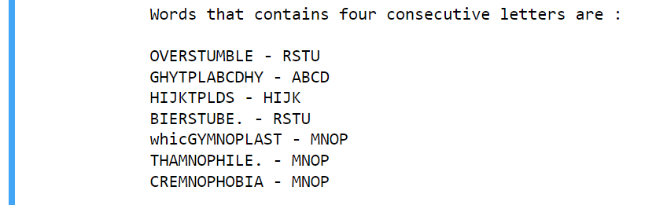

**Practical – 18**

**Aim :-** **Write a Python class to convert an integer to a roman numeral.**

**Code:-**

class irconvert:

num_map = [(1000, 'M'), (900, 'CM'), (500, 'D'), (400, 'CD'), (100, 'C'), (90, 'XC'),(50, 'L'), (40, 'XL'), (10, 'X'), (9, 'IX'), (5, 'V'), (4, 'IV'), (1, 'I')]

def num2roman(self,num):

roman = ''

while num > 0:

for i, r in self.num_map:

while num >= i:

roman += r

num -= i

return roman

num=int(input("Enter any Number :"))

print("Roman Number is : ",irconvert().num2roman(num))

**Output:-**

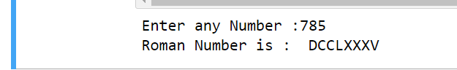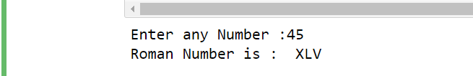

**Practical – 19**

**Aim :-** **Write a Python class to implement pow(x, n).**

**Code:-**

class py_pow:

def powr(self, x, n):

if x==0 or x==1 or n==1:

return x

if x==-1:

if n%2 ==0:

return 1

else:

return -1

if n==0:

return 1

if n<0:

return 1/self.powr(x,-n)

val = self.powr(x,n//2)

if n%2 ==0:

return val*val

return val*val*x

x=int(input("Enter x value :"))

n=int(input("Enter n value :"))

print("pow(x,n) value is :",py_pow().powr(x,n));

**Output:-**

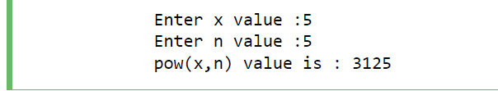

**Practical – 20**

**Aim :- Write a Python class to reverse a string word by word.**

**Code:-**

class py_reverse:

def revr(self, strs):

sp=strs.split()

sp.reverse()

res=" ".join(sp)

return res

str1=input("Enter a string with 2 or more words : ")

print("Reverse of string word by word: \n",py_reverse().revr(str1))

**Output:-**





**Practical – 50**

**Aim :- Write a function that uses the input dialog to prompt the user for a**

**positive integer and then checks the input to confirm that it meets the**

**requirements.**

**Code:-**

while True:

number = input("Enter a number: ")

try:

val = int(number)

if val < 0:

print("Sorry, input must be a positive integer, try again")

continue

break

except ValueError:

print("That's not an int!")

print("The Number ",val," is positive integer ")

**Output:-**

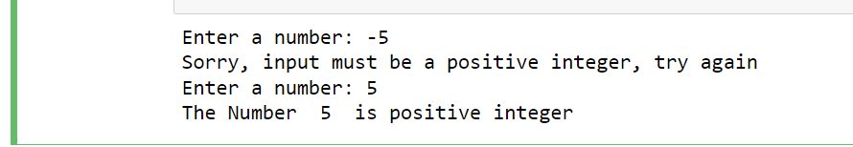

**Practical – 51**

**Aim Write a program that gets two command line arguments and checks**

**that the first argument represents a valid int number and second**

**argument represents a float number and display sum of those. Make**

**useful feedback if they are not.**

**Code:-**

def sum(n,k):

try:

val=int(n)

val1=float(k)

if (n==val and k==val1):

raise ValueError

else:

print(val+val1)

except ValueError:

print(" Pls Enter [num1==integer] value")

a=input("Enter num_1:")

b=input("Enter num_2:")

print(sum(a,b))

**Output:-**



**Practical – 52**

**Aim :- Write a Python program to find all words which are at least 4 characters long in a string.**

**Code:-**

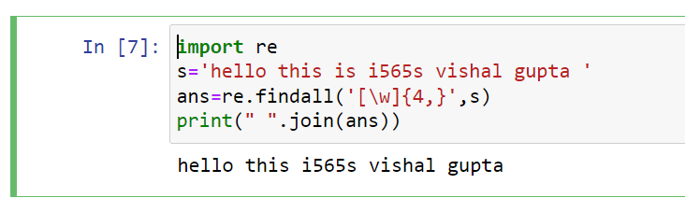

**Practical – 53**

**Aim :- Write a Python program to remove everything from a string except**

**alphanumeric characters .**

**Code:-**

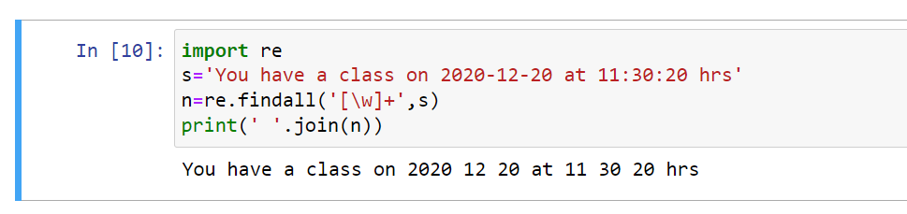

**Practical – 54**

**Aim :- Write a Python program to check a string containing decimal with a**

**precision of at most 2.**

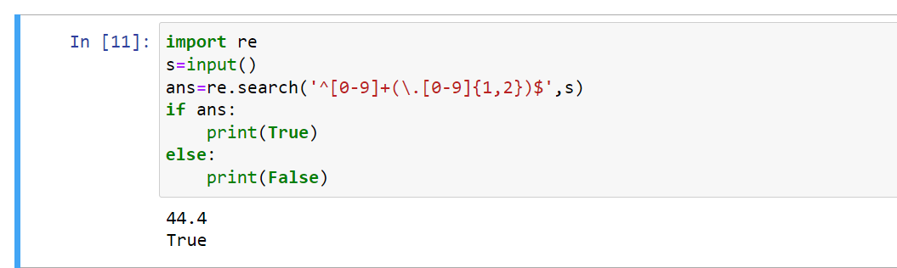**Code:-**

**Practical – 55**

**Aim :- Create Regular Expression for following” Match for stings that**

**start with From and characters (if any) followed by a two digit**

**number between 00 and 50, followed by : .**

**Code:-**

import re

s='Fromhsfgu34: ejhri3 hriwree Fromhsfgu44: uyuy Fromhsfgu11: gupta cse Fromhsfgu301: ruy '

ans=re.findall('From.[^0-9]*?[0-4][0-9]:',s)

for i in ans:

print(i)

**Output:-**

